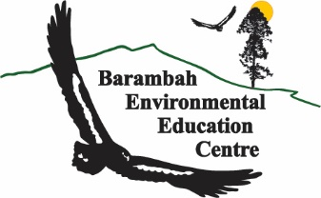

**Bike Camp**

**Barambah Bike Camp**

**June 19-21**

**Years 7-9**

We are looking for an interested, passionate and diverse group of students to engage in cycling development and adventure from across the North-Coast – Wide Bay Area. The inaugural Barambah Bike Camp is an initial step to develop local cycling, and specifically MTB, programming and events.

The Program will include:

* 3 Days Cycling program at Barambah Environmental Education Centre (ACARA-based)
* 9 meals and snacks
* Accommodation & Supervision
* Bike (Specialised MTB) & Helmet use where needed
* Limited numbers (30)

There is no cost to apply. Successful applicants will be required to pay a participation cost of $270 per student by 10/06/2024

If you are in a High School Student in Year 7, 8 or 9 and are wondering if you are the right sort of person to apply………. The answer is yes you are.

Applicant Details

|  |  |  |  |  |
| --- | --- | --- | --- | --- |
| **Student Name:** | |  | | |
| Date of Birth: |  | | Grade |  |
| Email: |  | | | |
| **Parent/Guardian Name:** | |  | | |
| Email: |  | | | |
| Phone: |  | | Signature: | 🗶 |
| **School Supporting Teacher Name:** | |  | | |
| Email: |  | | | |
| Signature: | | 🗶 | | |
| **Principal/Deputy/HOD Name:** | |  | | |
| Signature: | 🗶 | | Position: |  |

Complete this form and email to admin@barambaheec.eq.edu.au to submit your application.

Further Information

Timeline:

* Applications are open and close on Friday 24th May
* After your application is submitted you may be contacted for further information including medical information and media permissions
* Applicants and schools notified of selection by Friday 31st May
* Payment due June 10th or by arrangement.
* Camp from 10:00am on Wednesday 19 June to 1:30pm on Friday 21st June

Cost:

There is no cost to apply. Successful applicants will be required to pay a participation cost of $270 per student by 10/06/2024

School support / endorsement:

We request school support to know that this co-curricular activity will not affect educational progress and to alert schools of absence on activity and for invoicing purposes.

Complete this form and email to admin@barambaheec.eq.edu.au to submit your application. The Barambah team are all very excited to be receiving these applications - thank you for getting to this point.

**Want more adventure:**

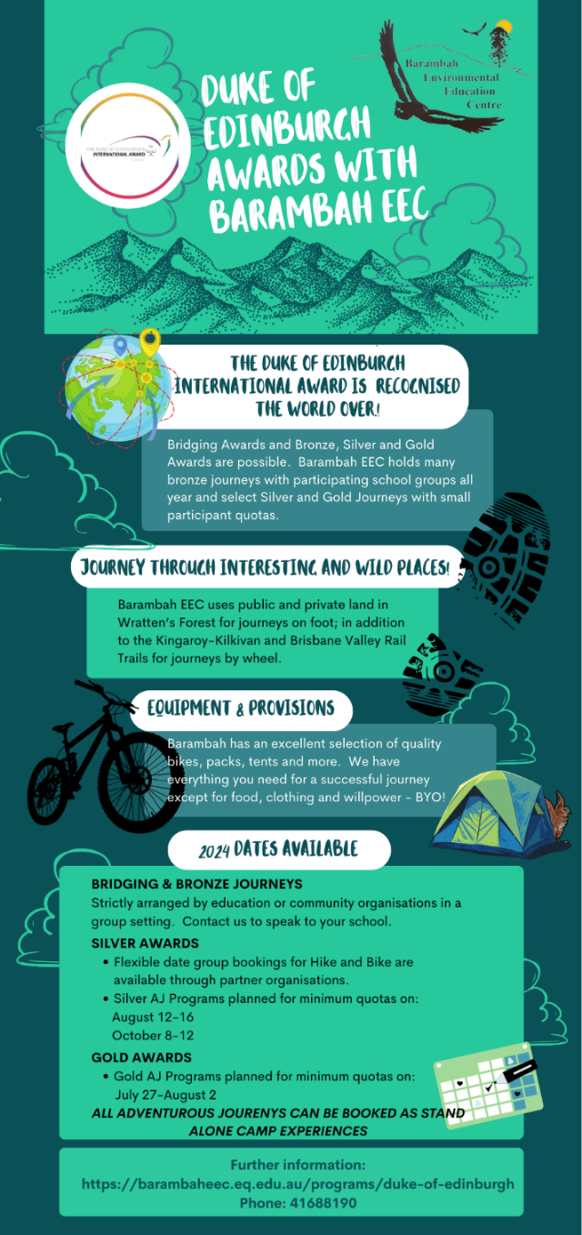



Barambah EEC is on Wakka Wakka Country on an ancient pathway that connects first Nations’ people from the mountains to the sea. We pay our respects to the elders and first custodians of this special place of the past, present and for the future.

Barambah *Connects People and Place* and *Learning and Wellbeing* on the land, of the sky and for life.

Barambah is an Environmental Education Centre located in Wrattens Forest. It is open to community and educational organisations for learning and development purposes. Barambah EEC is advantageously situated in the middle of Wrattens National Park, Wrattens Conservation Park and Wrattens Resources Reserve enabling many adventures on wheel and foot.

Need a place for your organisation’s next event, camp or conference: call us on 0741688190; email Ben or Danny at admin@barambaheec.eq.edu.au.